Using MS Publisher 2016 to Design for Campus Monitors
by Kelly Penfold, Library Media Specialist
Lyons New Media Centre, Mills Memorial Library

Sizing for Campus Monitors
Not everyone has access to or experience with using Adobe Photoshop, so sometimes it’s difficult to design in the exact dimensions needed for digital signage on campus.
One of the more common pieces of software used on campus for designing is Microsoft Publisher. This document will help you set up your workspace to fit the various digital signage monitors across campus.
Currently (as of June 2017), most monitors on campus display at 1920 x 1080 pixels. This is a 16:9 ratio (widescreen, landscape). So, choosing to make a standard blank image in Publisher isn’t going to work (as that’s typically 8.5 x 11 inches in size, and portrait-oriented). In order to set up your work area to the right size, you’re going to need to set up a custom size in Publisher.
When Publisher first opens, you will see a window that looks like this:

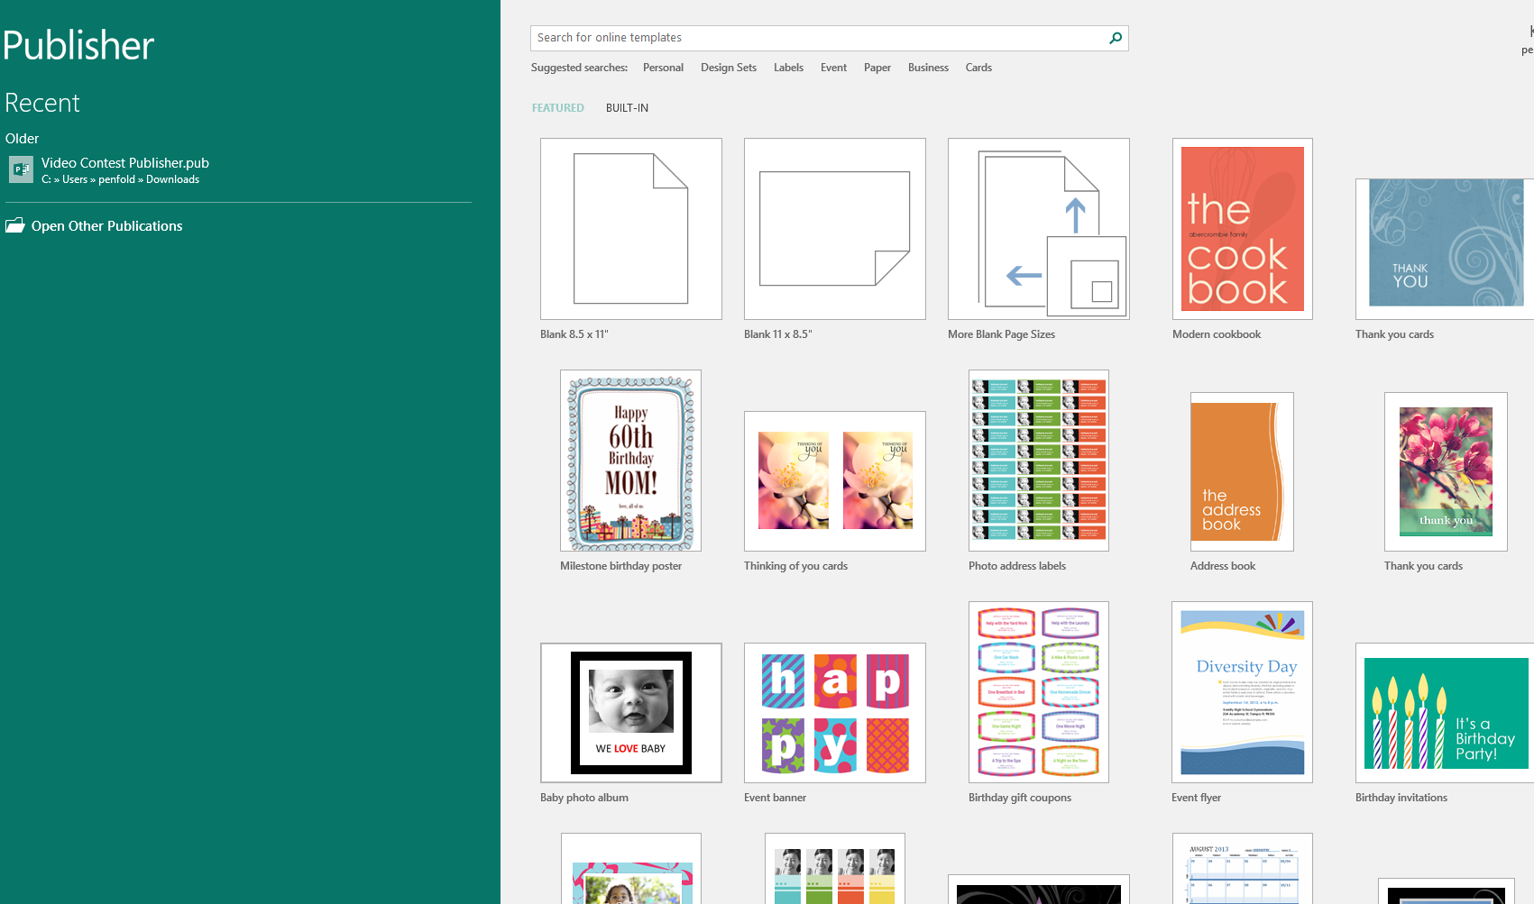

Most people just click on the first Blank 8.5 x 11” option, but as mentioned, this isn’t going to work for you in this case. Instead, choose More Blank Page Sizes:
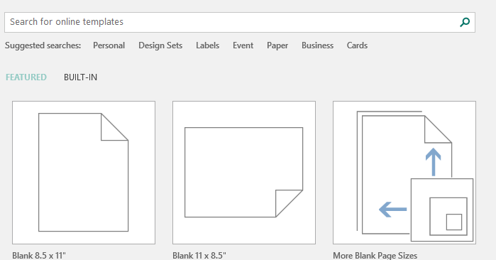
You will see a new window load called “More Blank Page Sizes” with a whole bunch of sizes to choose from. Choose the Create new page size… option in the Custom area.

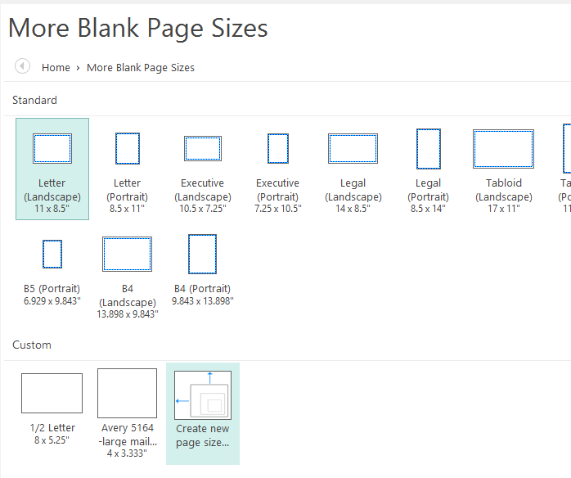
Once the Create new page size… choice has been clicked, you will see a window pop up in the middle of the screen that will look like this:

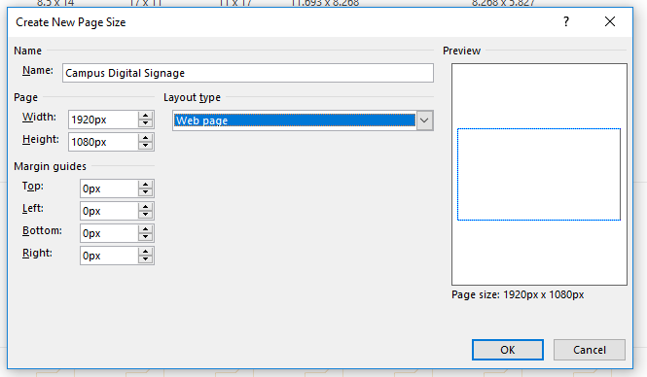

Take a moment to rename the new page size with something you will be able to recognize later when choosing a page size. In this instance, our new page size has been named Campus Digital Signage.
Under Layout type, be sure to choose Web page from the drop-down menu. Initially, it will say One page per sheet and will have page dimensions on the left in inches. To change this to pixels, we need to choose Web page.
Under the Page area to the left of Layout type, change the Width to 1920px. And next to Height, type 1080px. Once this is done, click the OK button.
Now, for some reason, this new page size doesn’t always show up in the More Blank Page Sizes screen, so here’s a work-around. Choose the first option you see, which is likely Letter (Landscape) 11x8.5”.

Then locate the Create button on the far right side of the screen:

You will initially see your new workspace set up something like this:

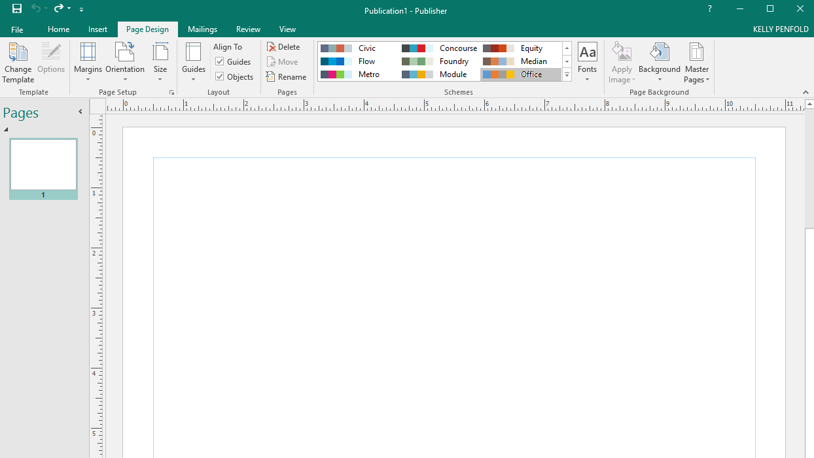

But we have to change this, as it is the wrong size. Click on the Page Design tab (seen above), then choose the Size icon to choose your newly created custom page size:
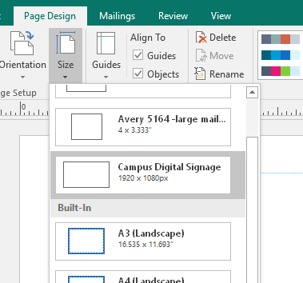
You will now see your workspace has changed considerably:

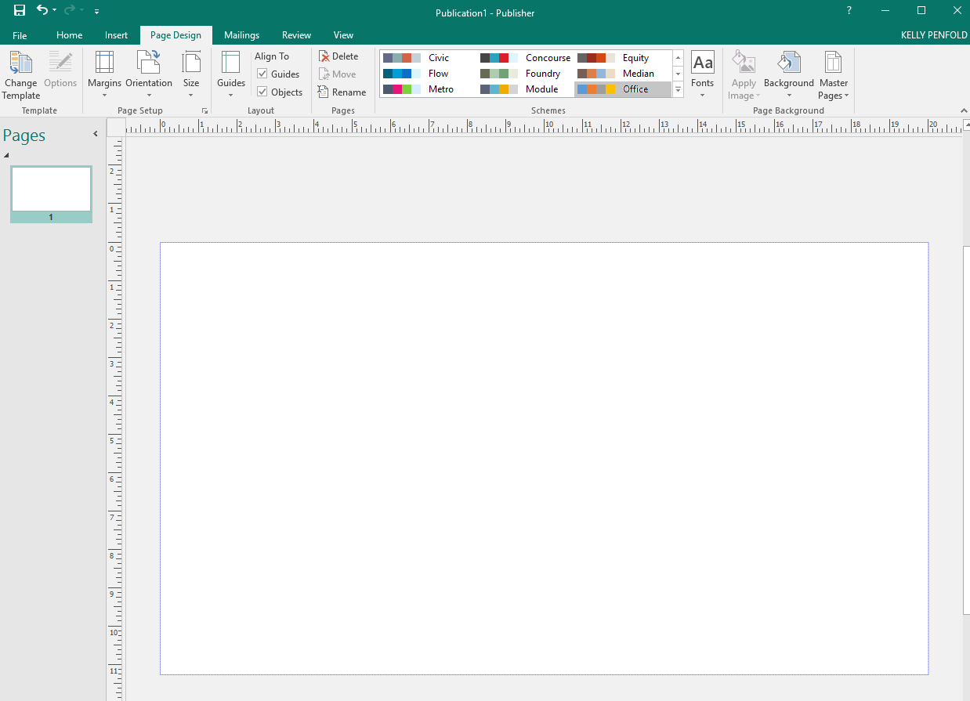

In the original setup, you will have seen the blue margin border set just a bit in from the outside of the white workspace. In this new setup, we told Publisher not to give this any margins (they all had 0px in the margin fields), so this means you can design from one edge to the other three. See in the above image how the blue line actually goes around the white workspace? This means you can design on all the whitespace shown. In the previous one, you would have been confined to working within those margin boundaries that were set just inside the workspace.
You are now ready to design! And once you save your image, it will save in the size required by monitors all over campus.

Saving to an Image File
One last thing you need to know before you send off your image to the Library, Residence Information System, or the MSU monitors: How to save your file as an image file.
The most common file type for the monitors across campus is a JPG. To save to a JPG format, be sure to change the file type when saving the file. When you have the Save As… dialogue box open, click on the Save As Type: drop-down menu:

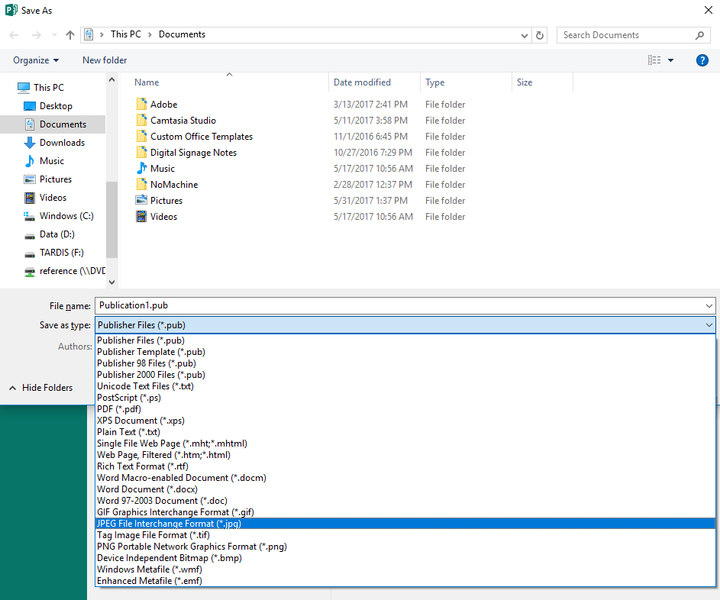

From there, be sure to choose JPEG File Interchange Format (*.jpg). Then save your file with a new name in the File name: field. All you have to do after that is choose where you are saving the file to, then click the Save button.
It is also recommended that you save a .PUB version of the file (your project file), too, in case you need to edit the image later on, as editing a JPG or PNG is often impossible after the fact.
That’s it!

