Using GIMP to Design for Campus Monitors
  - by Kelly Penfold, Library Media Specialist
Lyons New Media Centre, Mills Memorial Library

Sizing for Campus Monitors
Currently (as of June 2017), most monitors on campus display at 1920 x 1080 pixels. This is a 16:9 ratio (widescreen, landscape).
Not everyone designing on campus has Photoshop readily available, so some rely on GNU Image Manipulation Program – aka GIMP. This is a free designing program that can be downloaded for Windows, Mac OSX and Linux.
This help file is based on the Windows version of GIMP.
When you first open GIMP, this is what you will see:
The standard File, Edit… menu can be seen in the upper left corner of the screen, and several tools are available directly below that. To the far right appears to be for layers and brushes, having a similar basic layout to Photoshop.
To start your document, you’re going to need to set up the dimensions right from the start. This is fairly easy in GIMP. Click on the File menu in the top left corner of the screen.

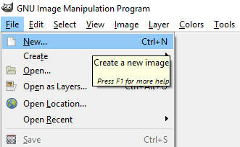

Initially, you will see a drop-down menu that has several options, starting with New…, Create, and Open… and so on. Click New… to start a new image. The Create New Image window will pop up, allowing you to set the appropriate dimensions.

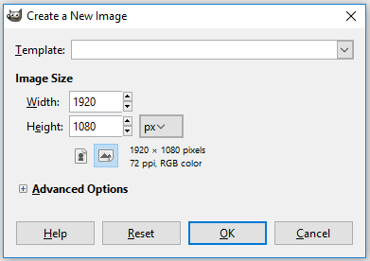

Here, you can just change the Width and Height accordingly to 1920px wide and 1080px high. From here, you can just click the OK button, or you can open the Advanced Options by clicking on the small box with a plus sign (+) in it to the left of the Advanced Options label. If you choose to change any Advanced Options, here’s what you will see:

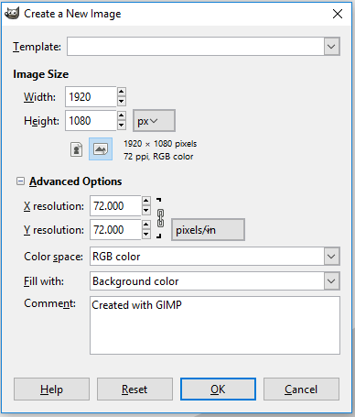

Here is where you can change the resolution of the image. Automatically, it is set to 72 dpi, which is fine for digital displays, but if you want to increase it, now is the time to do so. The higher the dpi, the higher the quality. Also, if you change the Fill with: to white or transparent, this can be useful if you have used GIMP already and the background has been changed to another colour. Click the OK button to continue once you have finished setting everything.
You will now see your workspace defined as a white rectangle in the middle of the grey workspace with an outline of black dashes on a yellow solid line. It will look like this:

Now you are ready to design!

Saving to an Image File
One last thing you need to know before you send off your image to the Library, Residence Information System, or the MSU monitors: How to save your file as an image file that these systems can use.
GIMP automatically saves in a format that GIMP understands (.xcf), so while it is encouraged to save a version in an .xcf format (think of this as your project file which saves all layer information, among other things), you will still need to save as a readable image file such as JPG or PNG.
To do this, you will also need to Export the file. To do this, go up to the File menu and open it. From there, choose Export As… and click this option. Export As… is an option just a few lines down from the Save As… option in this menu. Once you have chosen to export, you will see a window that looks very similar to the Save As… window.
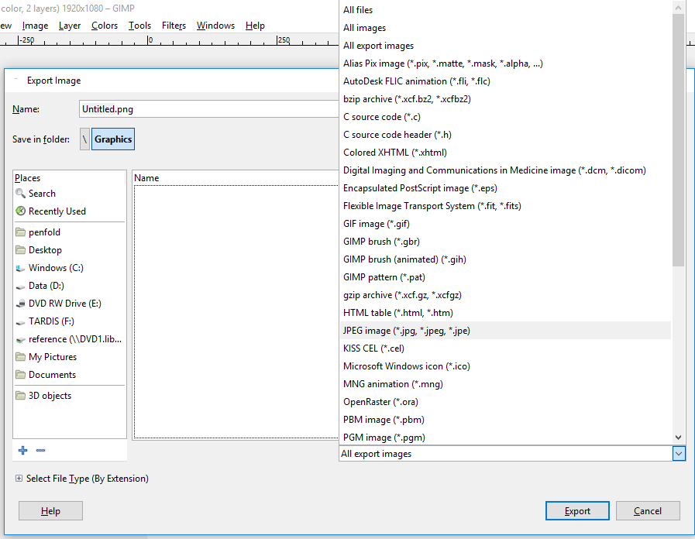

Export automatically saves your image as a PNG file, which is usually acceptable for campus signage. However, if you need to save it as another format, this is easily changed.
Once you choose what folder you will be saving your file in and have renamed your image (change Untitled.png at the top of this window), click on the All export images menu in the lower right corner of the Export Image window. It’s right above the Export button. From this list, you can change your file to any number of other image types, including JPEG image (*.jpg, *.jpeg, *.jpe), which is also an accepted file format for campus digital signage.
When you are done, click the Export button and you’re finished! (Don’t forget to save your project file, just in case you need to make any edits later, because you can’t edit a JPG or PNG later!)

