Kurzweil 3000 v14.00 Cheat Sheet
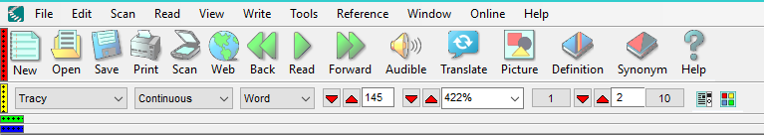

Kurzweil the Basics
Sign in – The login you choose saves your settings.
Toolbar – you can customize the toolbar by going to Tools -> Customize Toolbar. Drag any buttons you would like to use from inactive to the active toolbar
Open – You can open a PDF or Kurzweil formatted (.kesi) document.
Scan – This will scan an item using the scanner that is attached to your computer.
Web – You can open a web-page and have it read and highlighted by choosing this option
Reading Voices (First Drop-down) – Tracy is the default, but there are other options available
Reading Options (Second Drop-down) – Continuous – this option will read until you hit space
Self-paced – stops after each unit (which is something you set in the next drop-down menu)
Word by Word – this option only reads a word at a time until you tell it to go on
Reading Unit (Third Drop-down) – this determines how much is read, how far back and forward it will go. For example, if the reading unit is set as word, it will only read one word at a time, only go back one word and only go forward one word.

Writing with Kurzweil
New – creates a new word processing document.
Brainstorm – If you would like to start with brainstorming your essay. Write -> Brainstorm
Word Prediction – You can turn on Word Prediction. Tools -> Options -> Word Prediction. It will predict the word based on the first few letters that you have typed.
Read as you Type – To turn this feature on or off Tools->Options->General->Speak as Typing (Whole Words &Whole Sentences).
Adding to the dictionary – if you would like to add the words from your textbook Tools -> Word Lists -> Import.

Kurzweil Tools
Highlight – Tools -> Highlight you can select a variety of different colours to highlight concepts, terms, ideas, etc. Once you have highlighted the text, you can set Kurzweil to read only the highlighted sections by setting the reading unit to Highlight.
Footnotes – Tools -> Notes -> Footnotes Use these to add content at the bottom of each page in the word processing software.
Bubble Notes – Tools -> Notes -> Bubble Notes. Use these to add content at a specific spot on a page. Bubble Notes are a great way to mark a spot in the text where you had ideas relating to the content.
Sticky Notes – Tools -> Notes -> Sticky Notes. Use these to add content along the side of the page
Voice Notes – Tools -> Notes -> Voice Notes. You can create voice notes and place them anywhere in the text.
Column Notes – Tools -> Column Notes. You can copy content from the document into the column note and create ideas relating to these notes.
Bookmarks – Tools -> Bookmarks. Create bookmarks to be able to return to specific information. Choose whether to list the bookmarks in alphabetic or in order of appearance in the document. The bookmarks will appear in the green toolbar.
Show Only Notes – View -> Annotations Only check View Notes.

