# JAWS Cheat Sheet

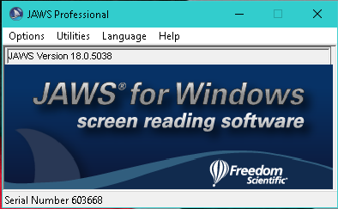

## The Basics

Changing the Voice – Options -> Voice -> Select a Voice Profile

Connecting to a Refreshable Braille Display – Options -> Braille -> Select Braille Display

## Keystrokes

<https://support.freedomscientific.com/Content/Documents/Manuals/JAWS/Keystrokes.pdf>