Dragon Naturally Speaking Help Sheet

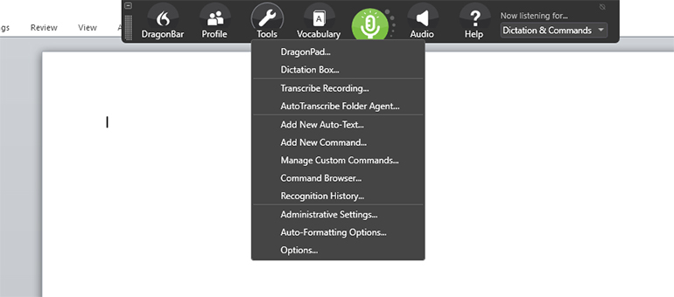

Common Commands
Open – to open another program
Stop – to stop dictation
Open Email – to open your default email program
Correct Vocabulary – this will ensure that it learns your voice and will pick it up correctly next time
Scratch That or Delete that – to delete what you just dictated

Tips and Tricks
Microphone – Position the microphone in the same spot each time, even if you have to mark it on your desk with tape
Quiet – try to ensure there is little background noise, this will affect the accuracy
Use Shortcuts – if you need to have the same long word or phrase typed out frequently, instead of saying it over and over again you can use shortcuts to program in, for example ‘work’ to type out ‘Mills Memorial Library, McMaster University’, add your frequently use phrases or words to the shortcuts or vocabulary list
Using Dragon in another program – To use Dragon with another program it doesn’t matter which program you open first. Turn the microphone on by clicking on the microphone icon, it should be green to begin dictation, and have the other program active on your desktop to begin transcription in the program.

